Ms. Bloss would like you to join 10th Grade!
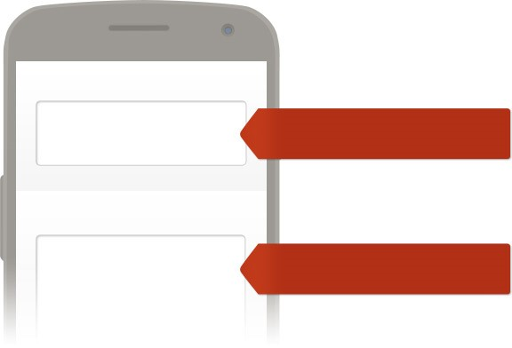
To receive messages via text, text @bloss10 to 81010. You can optout of messages at anytime by replying, 'unsubscribe @bloss10'.
WHAT IS REMIND AND WHY IS IT SAFE?
Remind is a free, safe, and simple messaging tool that helps teachers share important updates and reminders
with students & parents. Subscribe by text, email or using the Remind app. All personal information is kept
private. Teachers will never see your phone number, nor will you see theirs.
Visit remind.com to learn more.
To:
Message:
Enter this number
Text this message
81010
@bloss10
Trouble using 81010? Try texting @bloss10 to (972) 704-1292 instead.
*Standard text message rates apply.
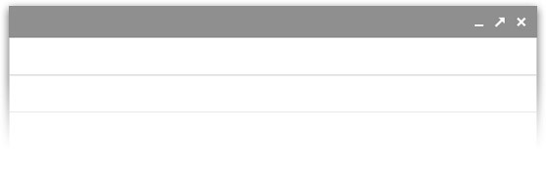
Or to receive messages via email, send an email to bloss10@mail.remind.com. To unsubscribe, reply with 'unsubscribe' in the subject line.
New message
Recipients
Subject
bloss10@mail.remind.com
(
You can leave the subject blank
)

