Ms. Bloss would like you to join English 4!
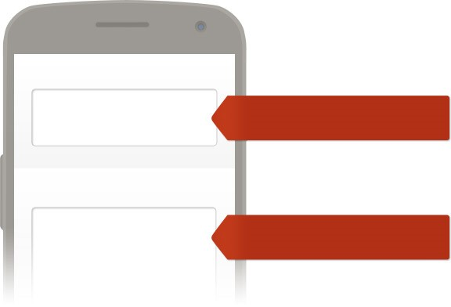
To receive messages via text, text @blosse4 to 81010. You can optout of messages at anytime by replying, 'unsubscribe @blosse4'.
WHAT IS REMIND AND WHY IS IT SAFE?
Remind is a free, safe, and simple messaging tool that helps teachers share important updates and reminders
with students & parents. Subscribe by text, email or using the Remind app. All personal information is kept
private. Teachers will never see your phone number, nor will you see theirs.
Visit remind.com to learn more.
To:
Message:
Enter this number
Text this message
81010
@blosse4
Trouble using 81010? Try texting @blosse4 to (972) 704-1292 instead.
*Standard text message rates apply.
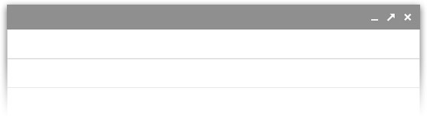
Or to receive messages via email, send an email to blosse4@mail.remind.com. To unsubscribe, reply with 'unsubscribe' in the subject line.
New message
Recipients
Subject
blosse4@mail.remind.com
(
You can leave the subject blank
)

